

**A Project Report On**

**“Analyze UBER Data in Python Using Machine Learning”**

**Under the Guidance of**

**Eckovation**

**Submitted By**

**Pratyush Hazarika**

**Roll No: 182050007002**

**Barak Valley Engineering College,Nirala,Karimganj,Assam**

**Preface**

Uber Technologies, Inc., commonly known as Uber, offers vehicles for hire, food delivery (Uber Eats), package delivery, couriers, freight transportation, and, through a partnership with Lime, electric bicycle and motorized scooter rental. The company is based in San Francisco and has operations in over 900 metropolitan areas worldwide. It is one of the largest providers in the gig economy and is also a pioneer in the development of self-driving cars.

**Acknowledgement**

It’s a matter of great pleasure to present this progress report on “Uber Data Analysis”. I am very grateful to Eckovation to give me the opportunity to build this project. I am also grateful to our ASTU coordinator along with Eckovation Faculty Members for their support and helping hand. Without them it was not possible to build.

**Content:**

1. Introduction ………………………………………………………………………...

2. Objectives of the project……………………………………………………...

3. Implementations………………………………………………………………….

4. Challenges..........................................................................

**Abstract**

Talking about our Uber data analysis project, data storytelling is an important component of Machine Learning through which companies are able to understand the background of various operations. With the help of visualization, companies can avail the benefit of understanding the complex data and gain insights that would help them to craft decisions.

**Introduction:**

Uber has a massive database of drivers, so as soon as you request a car, Uber’s algorithm goes right to work – in 15 seconds or less, it matches you with the driver closest to you. In the background Uber is storing data for every trip taken — even when the driver has no passengers. All of this data is stored and leveraged to predict supply and demand, as well as setting fares. Uber also looks at how transportation is handled across cities and tries to adjust for bottlenecks and other common issues. Uber also gathers data on its drivers. In addition to collecting non-identifiable information about their vehicle and their location, Uber also monitors their speed and acceleration, and checks to see if they are working for a competing company as well (such as Lyft). If you’re reading this wondering if it’s a gross invasion of privacy – you aren’t the first. But Uber is very clear about how it uses the data gathered on its platform. A section of its privacy policy for U.S. customers and drivers reads: 7 7 Uber uses your personal data in an anonymized and aggregated form to closely monitor which features of the Service are used most, to analyze usage patterns and to determine where we should offer or focus our Service. We may share this information with third parties for industry analysis and statistics.

**Objectives of this project:**

• Finding traveling time and Calculating the average speed of the trip.

• Visualizing the data in terms of trips per hour of the day, per day of the week, and per month of the year.

• From the above step finding out in which month highest trips are made.

**Implementation:**

1. **Importing necessary libraries:**

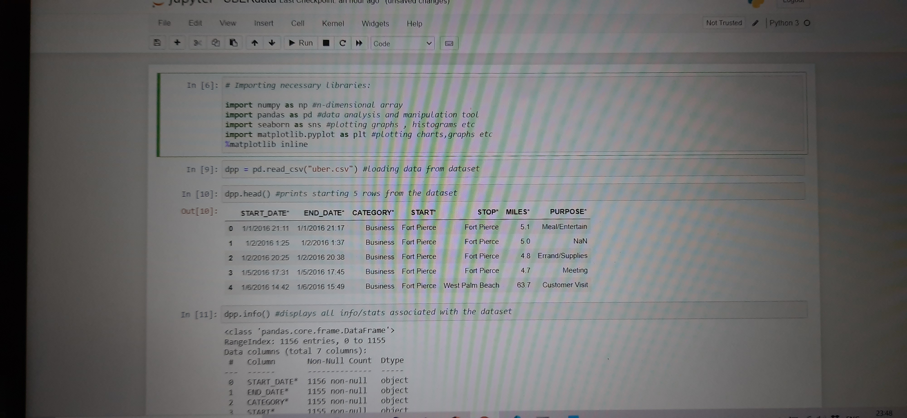

1. **Display the information associated with the dataset.**

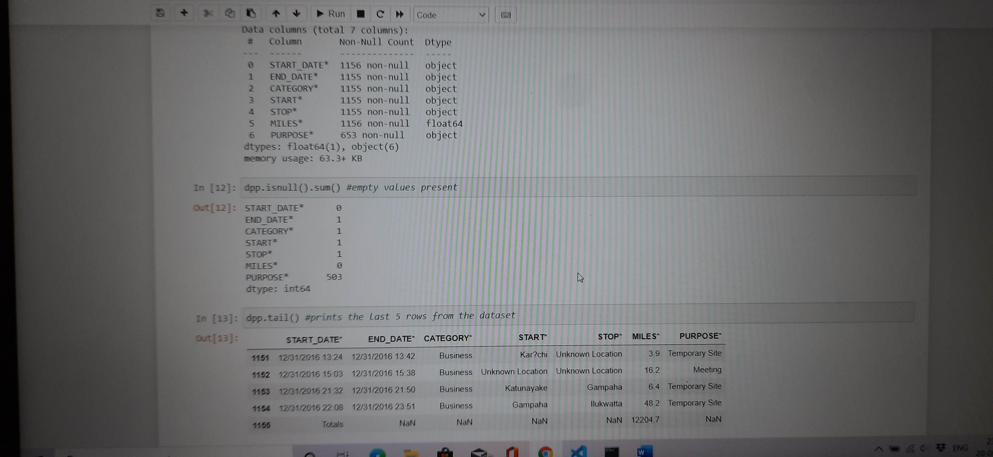

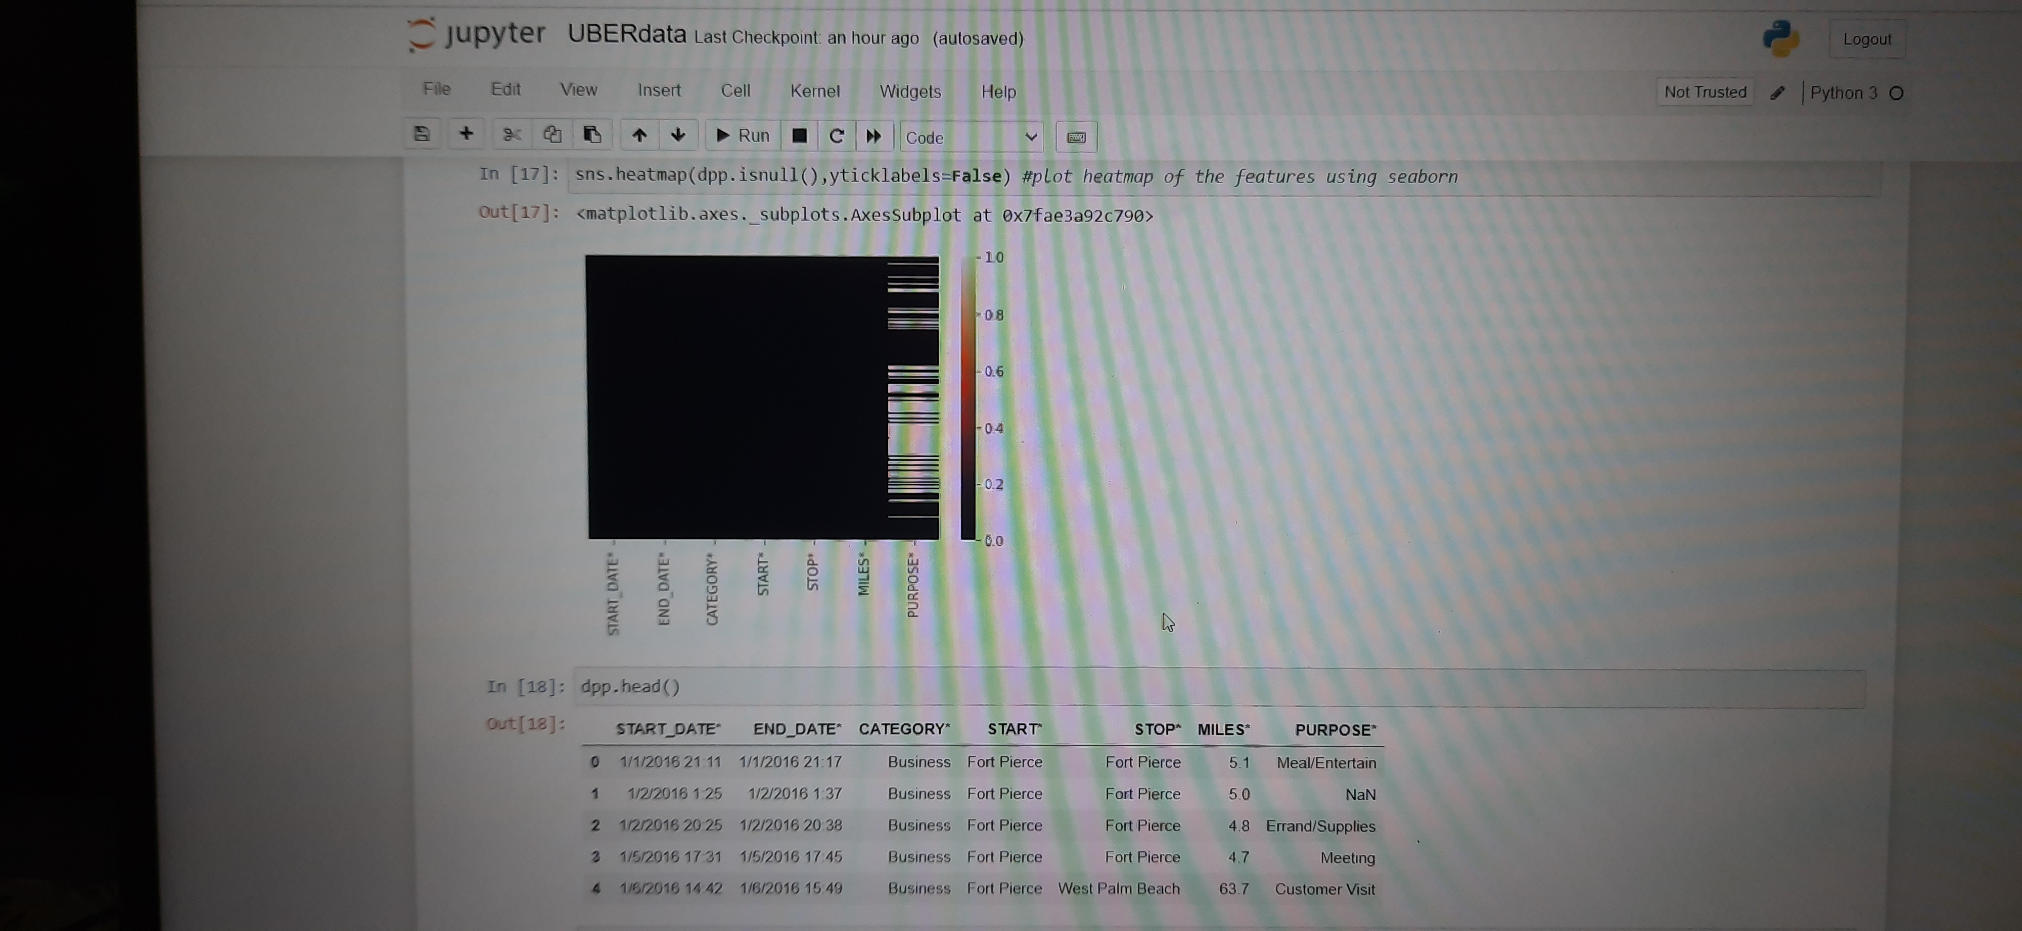

1. **Hour day transformation:**

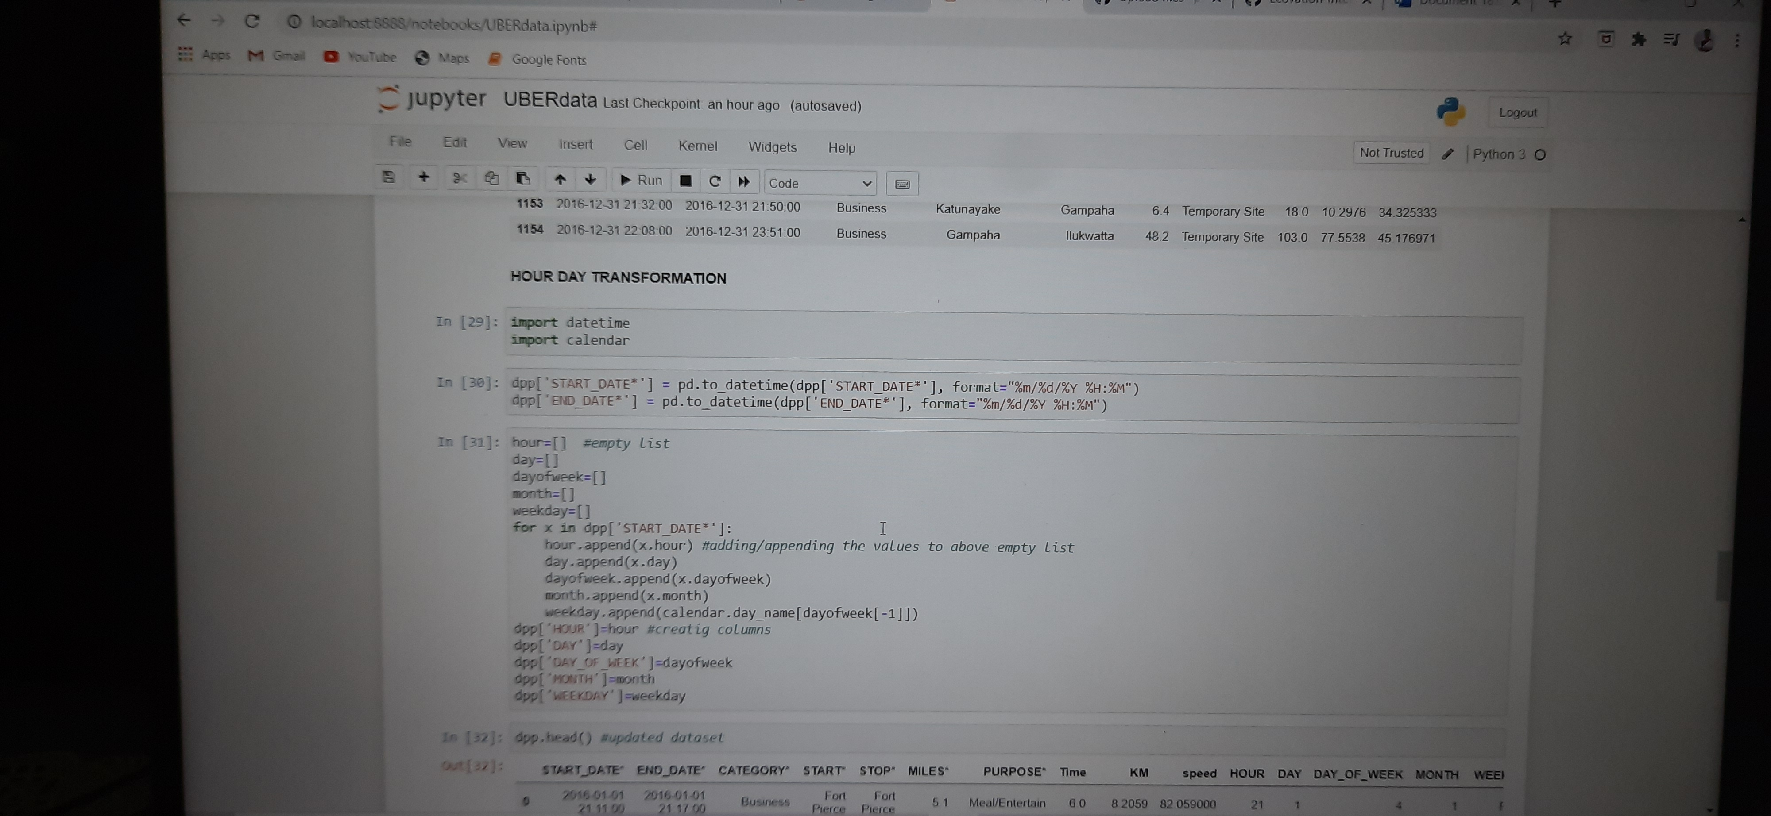

**Output of plotted graphs:**

**Heatmap:**

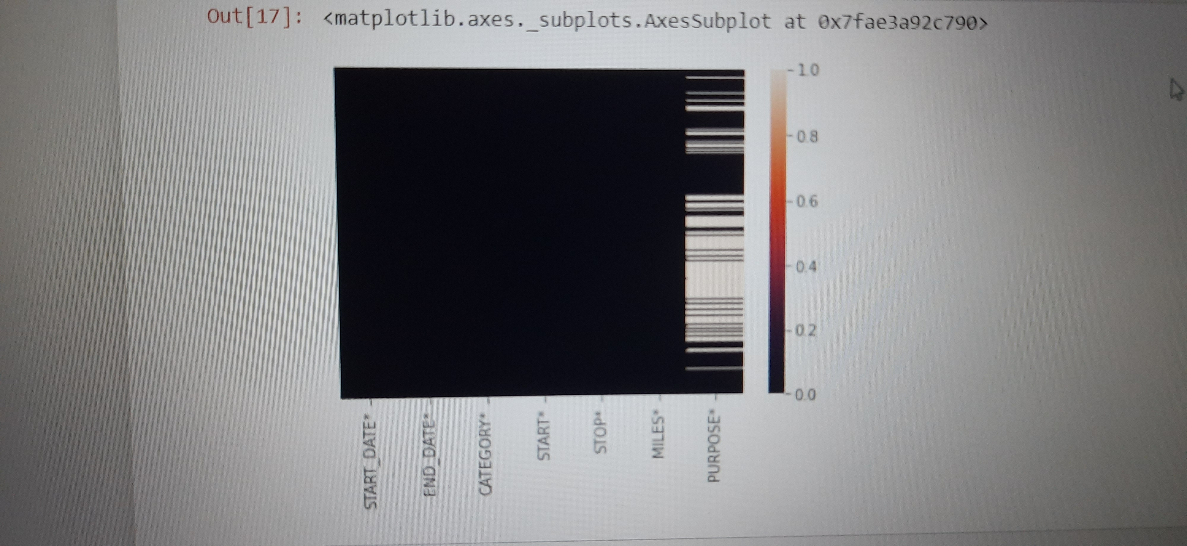

**Hour Graph:**

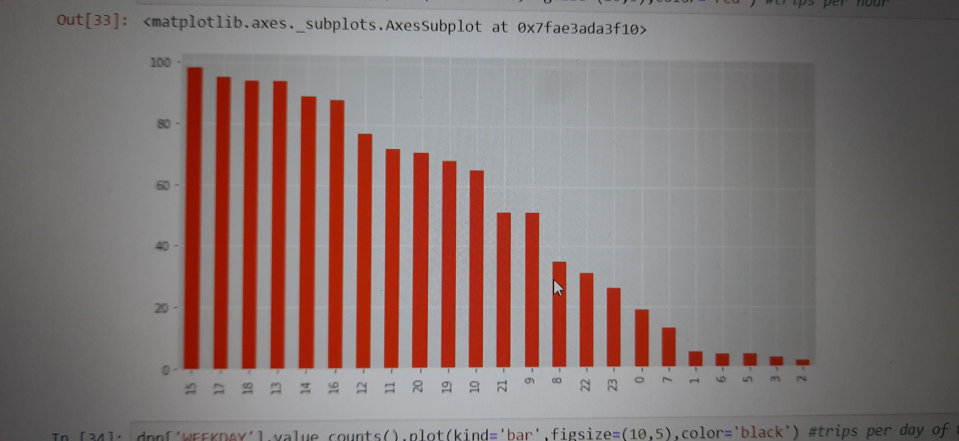

**Weekday graph:**

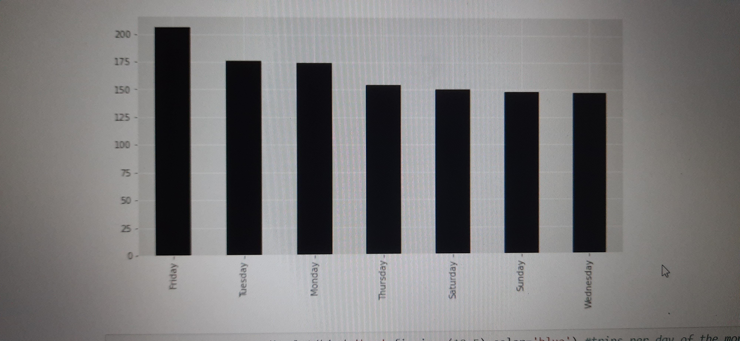

**Month of trip Graph:**

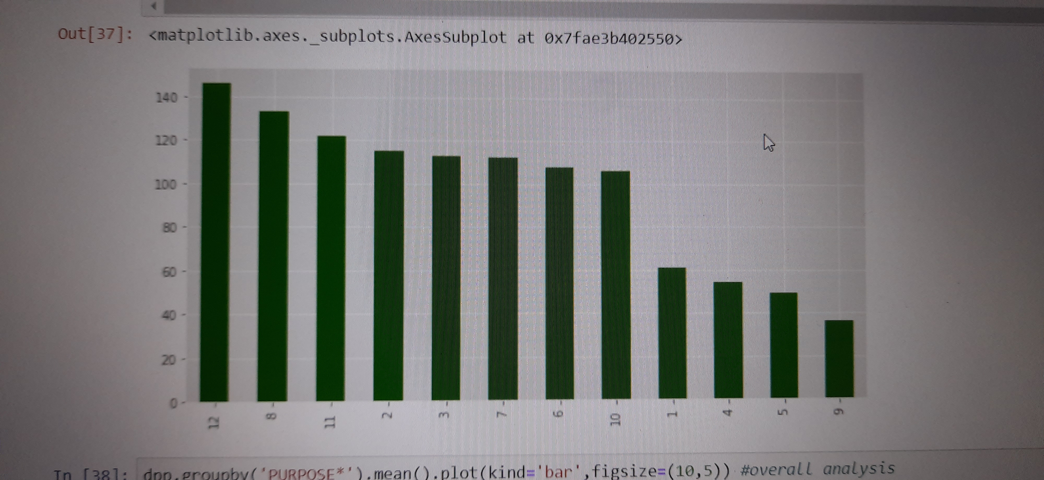

**From the above graph we found the highest number of trips take place in December.**

The Challenges:

• The data: The quality of the data determines the outcome of our model. Cleaning and processing the data, understanding it, playing with it, plotting it, cuddling it. Make sure you explore every aspect of it.

• Perhaps the most frequent challenge in big data efforts is the inaccessibility of data sets from external sources.

• It is necessary for the data to be available in an accurate, complete and timely manner because if data in the company's information system is to be used to make accurate decisions in time then it becomes necessary for data to be available in this manner.